**Pearson Correlation Co- efficient:**

In Simple words we can say that, it shows the strength and direction of the linear relationship between the variables. It holds good for linear data.

Here the values are ranging from **-1 to +1**

* If 2 variables are more towards **+1**, they are more positively correlated with each other.
* If 2 variables are more towards **-1**, they more negatively correlated with each other.

Formula to find the Pearson Correlation Coefficient.

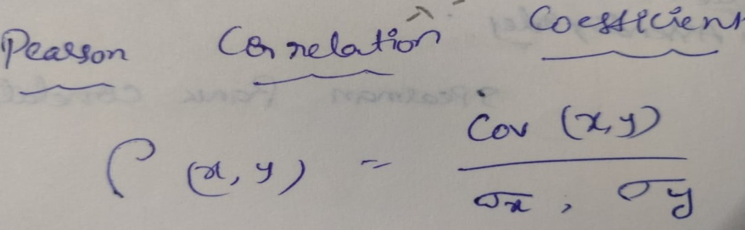

**Example:** Below is the example for clear understanding.

: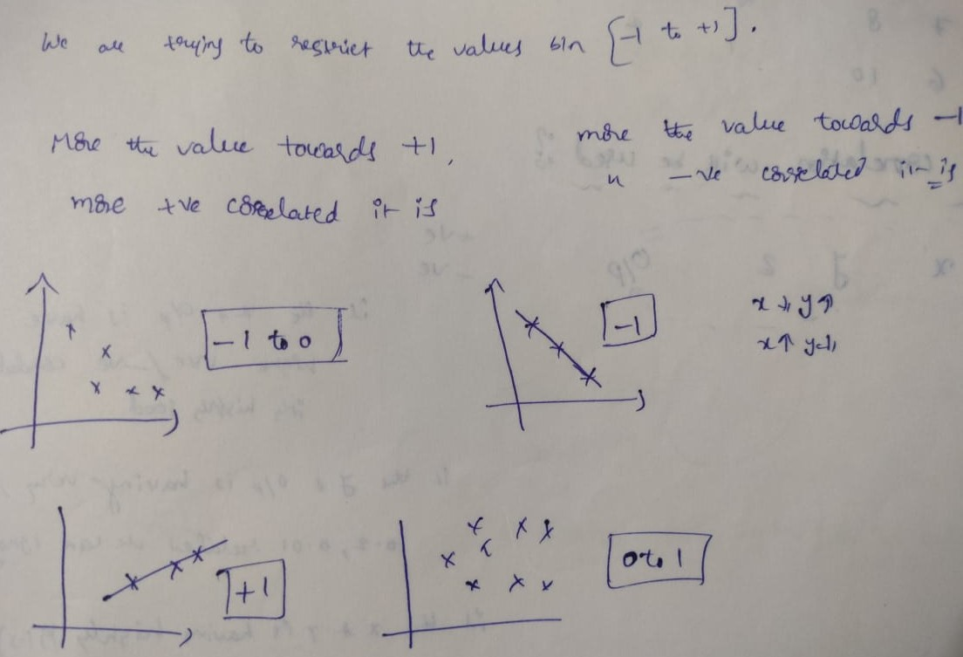

**Spearman Rank Correlation:** It holds good for non linear data. It assigns ranks.

Following is the formula

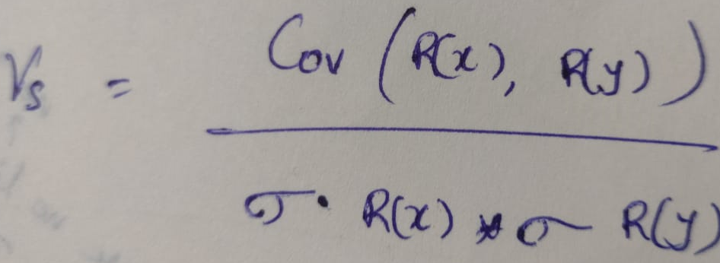

Example:

|  |  |  |  |
| --- | --- | --- | --- |
| X | Y | R(X) [Rank of X] | R(Y) [Rank of Y] (Ascending order) |
| 10 | 4 | 4 | 1 |
| 8 | 6 | 3 | 2 |
| 7 | 8 | 2 | 3 |
| 6 | 10 | 1 | 4 |